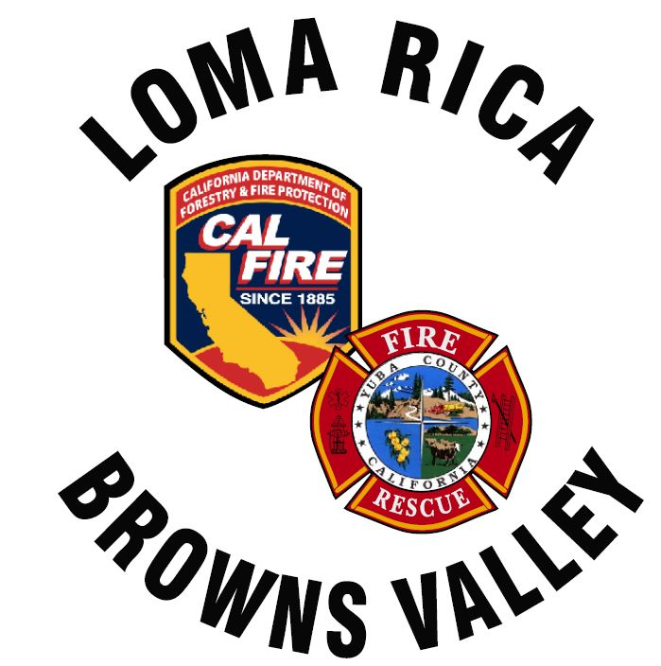
11485 Loma Rica Rd
Marysville, CA. 95901
530-741.0755
www.lrbvfire.org
lrbvcsd@lrbvfire.org
LOMA RICA/BROWNS VALLEY
COMMUNITY SERVICES DISTRICT

AGENDA
This meeting will be at 7:00pm at the Loma Rica Bi-Agency Fire Station
11485 Loma Rica Road Loma Rica, CA. 95901
This agenda has been prepared and posted at least 72 hours prior to the regular meeting of the Board in accordance with the Ralph M. Brown Act. All supporting documents are available, upon request, beginning at 6:30 pm the date of the meeting

DATE: October 20, 2025

- A) Roll Call: Biggs, High, Kattuah, McGahan, Yarborough
B) Pledge of Allegiance
2. PUBLIC COMMUNITCATIONS
Any person may speak on any subject or matter of concern, provided the subject or matter is within the jurisdiction of the Board of Directors for Loma Rica/Browns Valley CSD and is not already on the agenda. Those wishing to speak must state their name and place of residence to be heard. The Board limits testimony on such matters to 5 minutes per person but not more than 15 minutes total on a particular topic. The entire Public Communications section shall be limited to a total of 20 minutes unless the Chairman, subject to Board approval, sets different time limits.
NOTE: No Board action can be taken on comments made under this heading.

3. APPROVE MINUTES: September 15, 2025 meeting and October 8, 2025 Special meeting
4. ACCOUNTING: Finances
Warrants
5. CHIEF’S REPORT:
6. VOLUNTEER REPORT:

7. GENERAL MANAGERS REPORT:

OLD BUSINESS:
8. DISCUSS: Roadside signage

9. DISCUSS: Mitigation Study

10. DISCUSS: Purchase of new equipment

11. FIVE YEAR PLAN AD HOC COMMITTEE:

NEW BUSINESS:

12. DISCUSS AND APPROVE: Reserving rental fees as well as funds raised with the sale of E63 (2LR02) to go towards new equipment purchase.

13. BOARD AND STAFF MEMBER REPORT:

This time is provided to allow Board and staff members to report on activities or to raise issues for placement on future agendas.
A segment of time will be open during each Agenda Item for Public Comment/ Testimony
In compliance with the Americans with Disabilities Act, the meeting room is wheelchair accessible and disabled parking is available. Upon request, Agendas will be made available in alternative formats to accommodate persons with disabilities. If you have a disability-related modification or accommodations to participate in this meeting, please contact the district office at (530)741-0755 no later than 24 hours prior to the start of the meeting.

Board Packet: Available 30 minutes before beginning of this meeting:
09/15/2025 Minutes, 10/8/2025 Special Meeting Minutes
October Warrant request
Petty Cash transactions
October Financial Report

