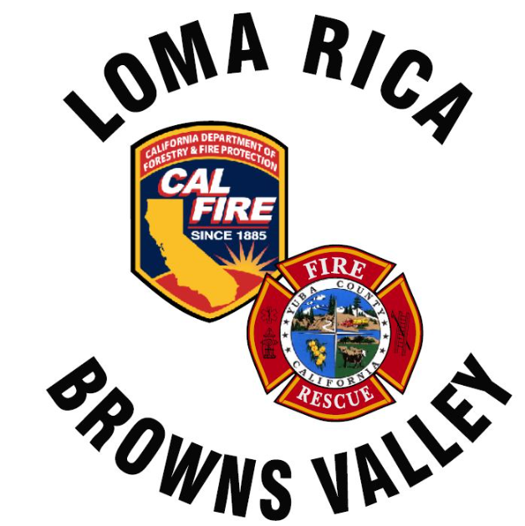
Monthly Report for LRBV

Month/Year: March/ 2026

 | St. 61
Medical Aid | 28
Public Assists | 7
Medical Rescues | 2
Vehicle Accidents | 4
Structure Fires | 0
Vegetation Fires | 0
Vehicle Fires | 0
False Alarms | 4
Hazardous Conditions | 1
Hazardous Materials | 0
Cover Assignments | 0
Assist to Allied Agency | 0
Total Responses | 46

News:
Agenda for next meeting
- No inquires on old E63
- All grants from Yuba water agency suspended until further notice. 3- 5 years for repairs with Colgate power house and pipe line.
- Chief McKeown will oversee the north Division with Chief Haacks retirement
- Station 61 will be going to Perm Firefighter II after July 1st- No effect on Amador cost.
- Email was sent to ISO representative to re open our evaluation. No response yet.
- 9600’ FT Hyatt construction building plans submitted on Marysville road across from Fruitland. For approval.
- Amador contract should be ready for April board meeting approval

Discussion items:
Station 62 remodel ?

Agenda items:
- Tablet command ( See attached Spread sheet)
- Equipment money for water tender 61 ( See attached)

