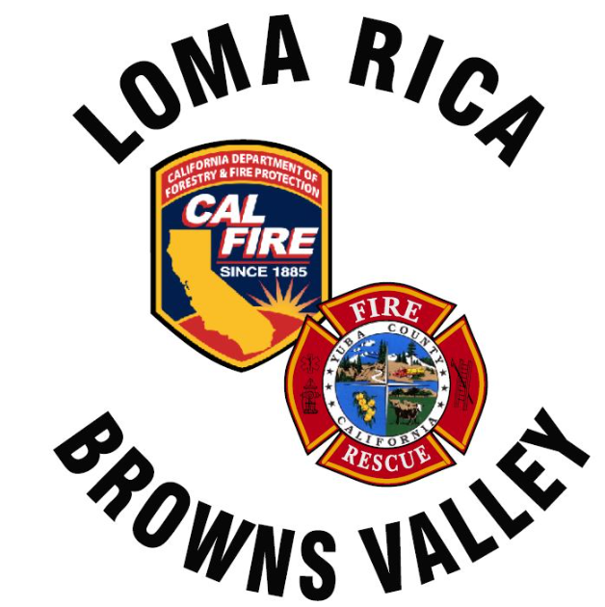
Monthly Report for LRBV

Month/Year: April 2026

 | St. 61
Medical Aid | 32
Public Assists | 6
Medical Rescues | 0
Vehicle Accidents | 7
Structure Fires | 2
Vegetation Fires | 2
Vehicle Fires | 1
False Alarms | 2
Hazardous Conditions | 1
Hazardous Materials | 0
Cover Assignments | 0
Assist to Allied Agency | 0
Total Responses | 53

News:
Agenda for next meeting
- No inquires on old E63
- ISO representative to re open our evaluation. With information provided he thinks it will push the district into class 4.
- Amador contract Delayed for May board meeting approval
- One of three prevention signs installed ( Marysville x Dolan Harding Road) should have the second and third installed by the end of the month.
- All hands meeting May 14th. E63 will be on static display. All board members are invited.
- New engine 61 started the assembly line with delivery in January
- Untz Festival scheduled the weekend of the 8th.

Discussion items:

Agenda items:

