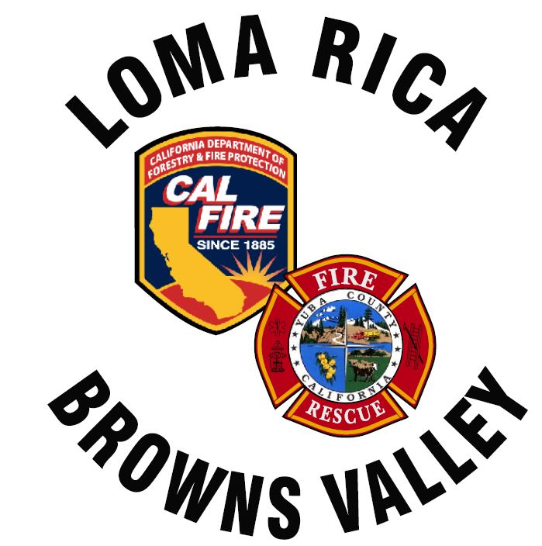
11485 Loma Rica Rd
Marysville, CA. 95901
530-741.0755
www.lrbvfire.org
lrbvcsd@lrbvfire.org
LOMA RICA/BROWNS VALLEY
COMMUNITY SERVICES DISTRICT

AGENDA
This meeting will be at 7:00pm at the Loma Rica Bi-Agency Fire Station
11485 Loma Rica Road Loma Rica, CA. 95901
This agenda has been prepared and posted at least 72 hours prior to the regular meeting of the Board in accordance with the Ralph M. Brown Act. All supporting documents are available, upon request, beginning at 6:30 pm the date of the meeting

DATE: March 16, 2026

- ROLL CALL: Biggs, High, Kattuah, McGahan, Yarborough
- PLEDGE OF ALLEGIANCE
- PUBLIC COMMUNICATIONS
Any person my speak on any subject or matter of concern, provided the subject or matter is within the jurisdiction of the Board of Directors for Loma Rica/Browns Valley CSD and is not already on the agenda. The Board limits testimony on such matters to 5 minutes per person but not more that 15 minutes total on a particular topic. The entire Public Communications section shall be limited to a total of 20 minutes unless the Chairperson, subject to Board approval, sets different time limits.
NOTE: No Board action can be taken on comments made under this heading

- APPROVAL OF MINUTES: February 16, 2026
- ACCOUNTING: Financial reports for the month of March
- DISCUSS/APPROVE: Warrants for the expenses of March 2026
- CHIEF’S REPORT:
- VOLUNTEER REPORT:
- GENERAL MANAGER REPORT:

OLD BUSINESS

- DISCUSS: Road signage
- FIVE YEAR PLAN AD HOC COMMITTEE:
- DISCUSS/APPROVE: Tablet Command (B. Skehan)

NEW BUSINESS
- DISCUSS/APPROVE: MOU with Placer County for the use of Tablet Command License. (B. Skehan)
- DISCUSS/APPROVE: Equipment purchase to have 3LR02 (WT61) outfitted upon arrival. (B. Skehan)
- DISCUSS/APPROVE: JPRIMA Insurance Renewal.
- DISCUSS/APPROVE: Contract with Smith and Newell to complete the 2023 and 2024 audit.
- DISCUSS/APPROVE: Purchase of PVC pipe to relocate wharf valve. (G. Yarborough)

- BOARD AND STAFF MEMBER REPORT:
This time is provided to allow Board and Staff members to report on activities or to raise issues for placement on future agendas.

A segment of time will be open during each Agenda Item for Public Comment/Testimony

In compliance with the Americans with Disabilities Act, the meeting room is wheelchair accessible and disabled parking is available. Upon request, agendas will be made available in alternative formats to accommodate persons with disabilities. If you have a disability-related modification or accommodations to participate in tis meeting, please contact he district office at (530)741-0755 no later than 24 hours prior to the start of the meeting.

Board Packet: Available 30 minutes before the start of this meeting:
2/16/2026 Minutes
March Financial Reports
March Warrant request
“Petty Cash” transactions
Chief’s Report
General Manager’s Report
Tablet Command handout
Water Tender 61 equipment
JPRIMA Policy
Smith & Newell Contract

