LOMA RICA / BROWNS VALLEY COMMUNITY SERVICES DISTRICT

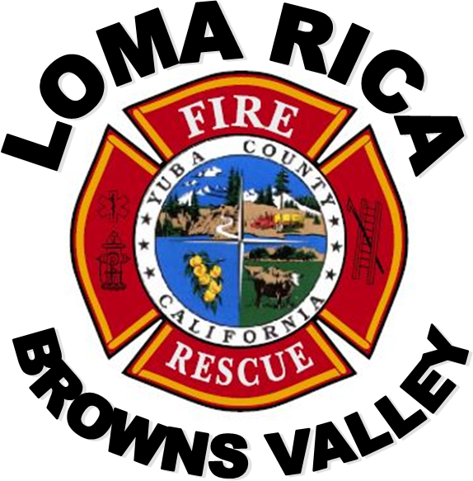

5 YEAR PLAN
2025 – 2030
LOMA RICA / BROWNS VALLEY COMMUNITY SERVICES DISTRICT 5-YEAR CAPITAL OUTLAY PLAN

2025-2030

Table of Contents

PURPOSE 4
The Plan: 4
EXISTING FIRE PROTECTION SYSTEM 5
Station 61 5
Station 62 6
Station 63 6
Engine 61 7
Engine 62 7
Engine 63 8
Engine 361 (on order) 8
Water Tender 62 9
Attack 61 9
Current Staffing 10
ISO Review 11
PLAN GOALS 12
Current and Projected Population 12
Call Volume and Locations 13
Type and Density of Structural Development 16
Response Times of Emergency Resources 16
Fire Flow Capabilities 17
Staffing Levels 18
FIRE PROTECTION OBJECTIVES 20
Fire Prevention 20
Objectives: 20
Fire Suppression 21
Objectives: 21
Emergency Medical Services 21
Objectives: 21
Technical Rescue 21
Objectives: 21

ADMINISTRATION 22
Objectives 22
TRAINING 22
Objectives 22
HAZARDOUS MATERIALS 23
Objectives 23
PERSONNEL 23
Objectives 23
COMMUNICATIONS 23
Objectives 23
I.S.O. RATING 23
Objectives 23
Loma Rica/Browns Valley CSD Fire Department Planning Goals 24
APPENDIX A 25
Map 25
APPENDIX B 26
Mitigation Funding 26
APPENDIX C 27
Capital Spending 27
APPENDIX D 28
Summary 28
APPENDIX E 29
Equipment 29
Fire Engine - Type I 29
Fire Engine - Type II / III (Wildland Interface) 29
Water Tender 30
Quick Attack Extrication Equipment 30

PURPOSE

This 5-year plan was last amended and approved by the District Board of Directors in 2025. A committee was formed and the document updated in the summer of 2025. This plan has been prepared to serve several purposes, including:

    - Serving as a guide for the District’s Board of Directors
    - Informing District residents, businesses, and other interested parties about the current and planned future configuration of the District’s fire protection services so they meet the community’s needs effectively and efficiently
    - Evaluate actual levels of service needed
    - Serving as a Capital Improvement Program (CIP) to support future financing decisions and allocations
    - Provide a format for department planning beyond one year

Where possible, we hope to emphasize prevention over suppression and provide direction to problems in advance of changes that force us to react after a catastrophe.

The district’s goal is to provide an organized approach to defining and maintaining the level of emergency medical service, rescue, fire prevention, fire protection and all emergency response, acceptable to the residents of the District and the elected Board of Directors.

The Plan:

      - Discusses the current and future fire/rescue and emergency medical protection environment
      - Discusses life and property risk levels
      - Discusses the optimal fire/rescue protection and emergency medical services, which provide the level of service commensurate with the level of accepted risk
      - Establishes policy in advance of change, permitting control of, rather than reaction to, the fire/rescue and emergency medical environment

This Plan will provide the Loma Rica / Browns Valley Community Services District (District) with a Fire Protection Plan that will be acceptable to its citizens, workable, and affordable. The Plan will address fire prevention, fire suppression, rescue response, all risk response, and emergency medical services for the five year span of 2025 through 2030.

EXISTING FIRE PROTECTION SYSTEM

The Loma Rica / Browns Valley Community Services District supplies fire suppression, rescue and medical aid to a population of approximately 6,500 people with 2,321 homes and businesses, spread out over roughly 98 square miles. The district was formed in 1984 which established the Community Services District governed by a 5-person Board of Directors.

The District contracts with the California Department of Forestry and Fire Protection (CAL FIRE) to supplement coverage. CAL FIRE provides a modern, full service fire protection and emergency incident management agency that provides comprehensive fire protection and other emergency incident response. Operationally, this results in additional fire equipment, at least two paid state firefighters on call 24 hours a day during the winter season (non-fire season for state wildland areas), professional training, and professional leadership. Also included are management support services that include fire department administration, training and safety, personnel, finance and logistical support.

The District operates from three fire stations:
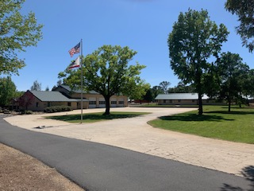
- Station 61 - Bi-Agency fire station (CAL FIRE and District) located at 11485 Loma Rica Road. Station 61, Loma Rica, is staffed through the CAL FIRE / District contract and houses one Type 1 HME Engine, one Type III International Engine, and one Type 3 fire Engine (belonging to CAL FIRE).

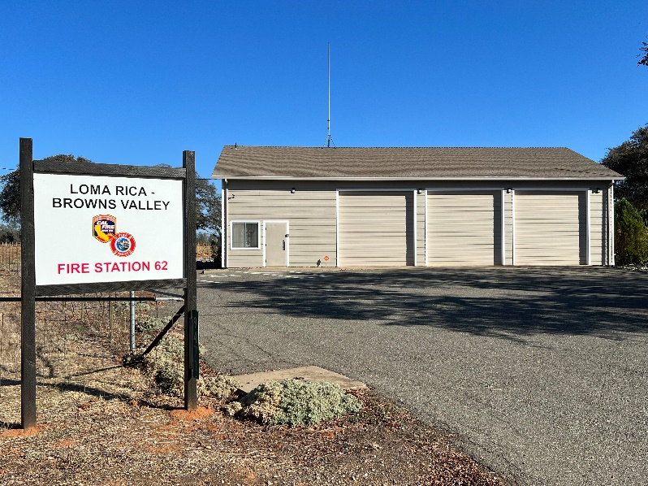
- Station 62 - Loma Rica Browns Valley station located at 9471 Browns Valley School Road. Station 62 is currently operated as unstaffed sub-stations housing one Type-1 International Engine.

3. Station 63 - Loma Rica Browns Valley station located at 6729 Marysville Road. Station 63 will house one Type VI Engine and one Freightliner Water Tender.
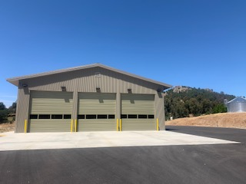
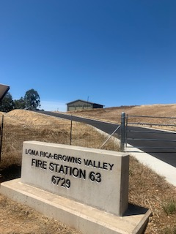

The District operates multiple pieces of emergency apparatus:

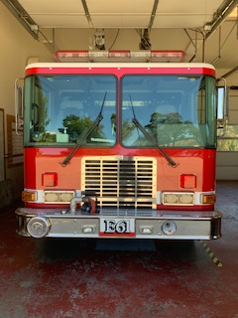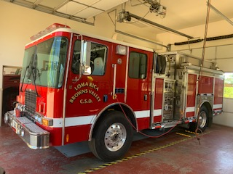

Fire Engine 61 (2LR01) Make: HME Model: Type 1
Year: 2012 Miles:29,473 Pump: 1250 GPM

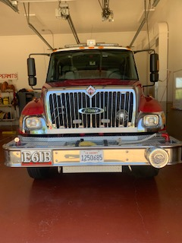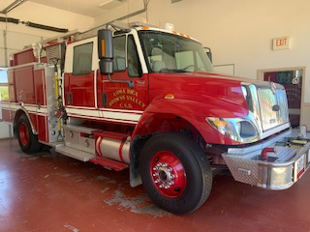

Fire Engine 62 (2LR02) Make: International Model: Type III
Year: 2006 Miles: 45,321 Pump: 1,000 GPM

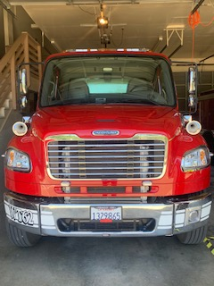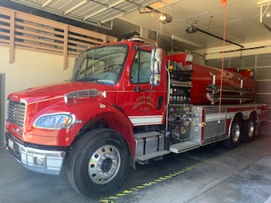

Water Tender 62 (3LR01) Make: Freightliner Model: 3000 Gallons
Year: 2012 Miles: 8,919 Pump: 1,000 GPM

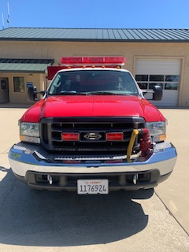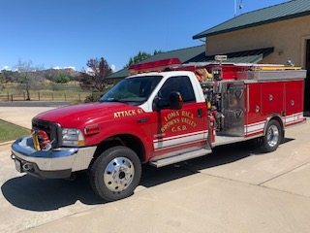

Attack 61 (1LR01) Make: Pierce Model: Type VI
Year: 2003 Miles: 17,702 Pump: 150 GPM

Current Staffing:

The District also has mutual and automatic aid agreements with the surrounding fire districts. Currently, staff consists of 1 paid position, General Manager, and varying volunteer members. The current I.S.O. (Insurance Service Office) rating for the District is 4 for areas within 5 miles of either of the fire stations. All other areas of the District are class 4Y.

Through the contract with CAL FIRE, the District is able to take advantage of the existing CAL FIRE administrative structure, including the Unit Chief that performs the duties of the district Fire Chief, Battalion Chiefs that provide local command and control, and professional company officers including Fire Apparatus Engineers and Fire Captains. Fire Prevention and Investigation can be provided by CAL FIRE Prevention Officers who are Peace Officers. This includes many fiscal advantages of the district not paying a full time professional staff. CAL FIRE pays for all mandatory training, physical exams, benefits, worker’s compensation, and the vast majority of all salaries for their state employees. Additionally, the District benefits from access to state resources, including purchase contracts.

As part of their duties during the Amador period, CAL FIRE personnel inspect all business in the District on an annual basis and perform PRC 4291 inspections year round as required by law. In conjunction with local school authorities, CAL FIRE personnel also perform yearly fire safety presentations at each of the local schools. Historically, there have been few emergency water supply systems constructed within the district. Fire hydrants are not being properly maintained by the private owners. Fire suppression for the majority of the properties served within the District depends on water transported to the incident and / or the ability of responding equipment to pump water from available water sources, i.e. ponds and irrigation ditches. Currently, the County of Yuba is requiring all new residential structures to install a minimum 3,000 gallon emergency water storage tank prior to commencing construction. Additionally, owners of existing residential structures wishing to obtain permits for property improvement must first install a minimum 3,000 gallon emergency water storage tank as an integral requirement for obtaining the requested permit.

While ultimate responsibility lies with each independent fire district, plans for new subdivisions are currently reviewed and conditions are formulated by the CAL FIRE Battalion Chief to insure compliance with California Fire Code. All of these items are required by ISO as part of the Fire Department Fire Protection Rating system. If these tasks were not performed it would adversely affect the District’s current class 4 / 4Y rating.

ISO Review:

In the summer of 2025 the district was evaluated by ISO (Insurance Service Office) and received a 4/ 4Y rating. ISO's PPC program evaluates communities according to a uniform set of criteria,
incorporating nationally recognized standards developed by the National Fire Protection
Association and the American Water Works Association. A community's PPC grade
depends on:
- Needed Fire Flows, which are representative building locations used to determine
the theoretical amount of water necessary for fire suppression purposes.
- Emergency Communications, including emergency reporting, telecommunicators,
and dispatching systems.
- Fire Department, including equipment, staffing, training, geographic distribution of
fire companies, operational considerations, and community risk reduction.
- Water Supply, including inspection and flow testing of hydrants, alternative water
supply operations, and a careful evaluation of the amount of available water
compared with the amount needed to suppress fires up to 3,500 gpm.

It is important to understand this point system that a fire department can change so we can improve the rating and potentially make the community safer while reducing the cost to residents for fire insurance.

Below are the elements with their corresponding point structure:

- A review of the Emergency Communications accounts for 10% of the total classification.
This section is weighted at 10 points, as follows:
  - Emergency Reporting 3 points
  - Telecommunicators 4 points
  - Dispatch Circuits 3 points
- A review of the Fire Department accounts for 50% of the total classification. ISO focuses on a fire department's first alarm response and initial attack to minimize potential loss. The fire department section is weighted at 50 points, as follows:
  - Engine Companies 6 points
  - Reserve Pumpers 0.5 points
  - Pump Capacity 3 points
  - Ladder/Service Companies 4 points
  - Reserve Ladder/Service Trucks 0.5 points
  - Deployment Analysis 10 points
  - Company Personnel 15 points
  - Training 9 points
  - Operational considerations 2 points
  - Community Risk Reduction 5.5 points (in addition to the 50 points above)
- A review of the Water Supply system accounts for 40% of the total classification. ISO
reviews the water supply a community uses to determine the adequacy for fire suppression
purposes. The water supply system is weighted at 40 points, as follows:
  - Credit for Supply System 30 points
  - Hydrant Size, Type & Installation 3 points
  - Inspection & Flow Testing of Hydrants 7 points
- The score is subject to modification by a Divergence Factor, which recognizes disparity between the effectiveness of the fire department and the water supply. The Divergence factor mathematically reduces the score based upon the relative difference between the fire department and water supply scores. The factor is introduced in the final equation. 6 points
The following are the points given to the district for the September 2025 review:

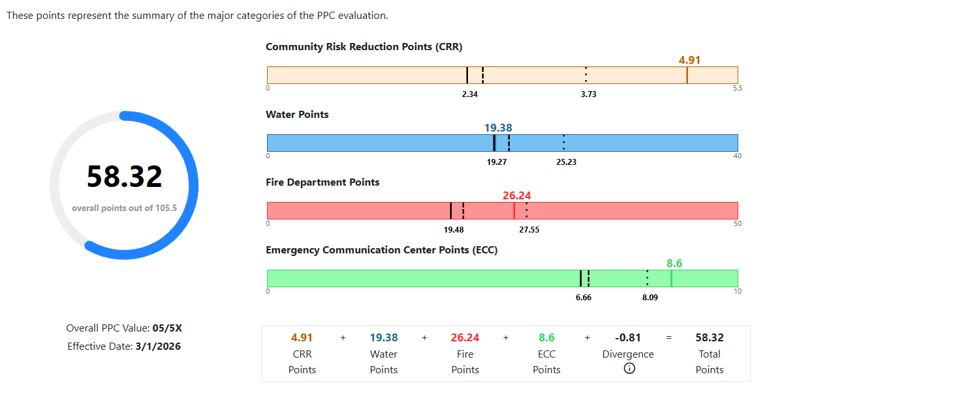
Any changes the District makes to the key areas can be submitted to change the rating. Ultimately this has the potential for substantial cost savings to residents on their insurance rates. It should also be noted that many insurance companies have created their own proprietary protection rating system that may or may not include ISO ratings.

PLAN GOALS

In order to develop a reasonable plan, certain assumptions are required. The following assumptions are based on District characteristics and nationally recognized standards:

      - Current and projected populations
      - Call volume and locations
      - Type and density of structural development (fire load)
      - Response times of emergency responses
      - Fire flow capabilities
      - Staffing needs

Current and Projected Population

Calls for service increase proportionate to an increase in population. Increase in population directly relates to an increased need for higher levels of service. Although specific figures for the Loma Rica / Browns Valley areas are not available, information presented in an economic forecast prepared by the California Department of Transportation indicates that Yuba County population as a whole will grow an average of 1.3% per year. The District is seeing an increase in construction of additions to residences, detached garages and shops, as well as the 2017 opening of a 9,100 square foot Dollar General store in Loma Rica thus increasing the “protection square footage inventory”. Growth of other surrounding districts / areas increases the traffic burden on the roads passing through the District, resulting in an increase of vehicle accidents. For planning purposes, growth within the district should be considered equal or greater than the unincorporated areas as a whole.

Call Volume and Locations

Historical calls for service are an indication of possible future needs for response and can be a guide on where to focus resources. Over the last 3 years incident activity and locations were collected to give a possible indication of needs over the next few years. The district responded to an average of 621 incidents annually over that 3 year period. 55% of those calls were medical aids followed by traffic accidents which were 28% of the incidents.

The majority of incidents can be classified as calls for medical assistance making up approximately 83% of total responses. Response times for emergency medical service calls are especially critical. Common sense, as well as numerous studies has substantiated the requirement for rapid initiation of Basic Life Support (BLS). Advanced Life Support (ALS) follow up can substantially increase both survivability and comfort to patients in need. In the future the District may be able to provide Advanced Life Support. In 2019 CAL FIRE implemented an advanced scope of medical care training for all employees which includes Epinephrine, Narcan, and airways. This level of care will meet critical needs and bridge the gap until full ALS can be implemented by First Responders in the District. Frequently ALS delivery to patients in the district is delayed by ambulances responding from the Marysville/Yuba City area. A goal of the District is to develop reasonable and sustainable avenues to deliver ALS to residents.

Visual representations of those incidents are included below:

2020-2025 Combined Point and Heat Map

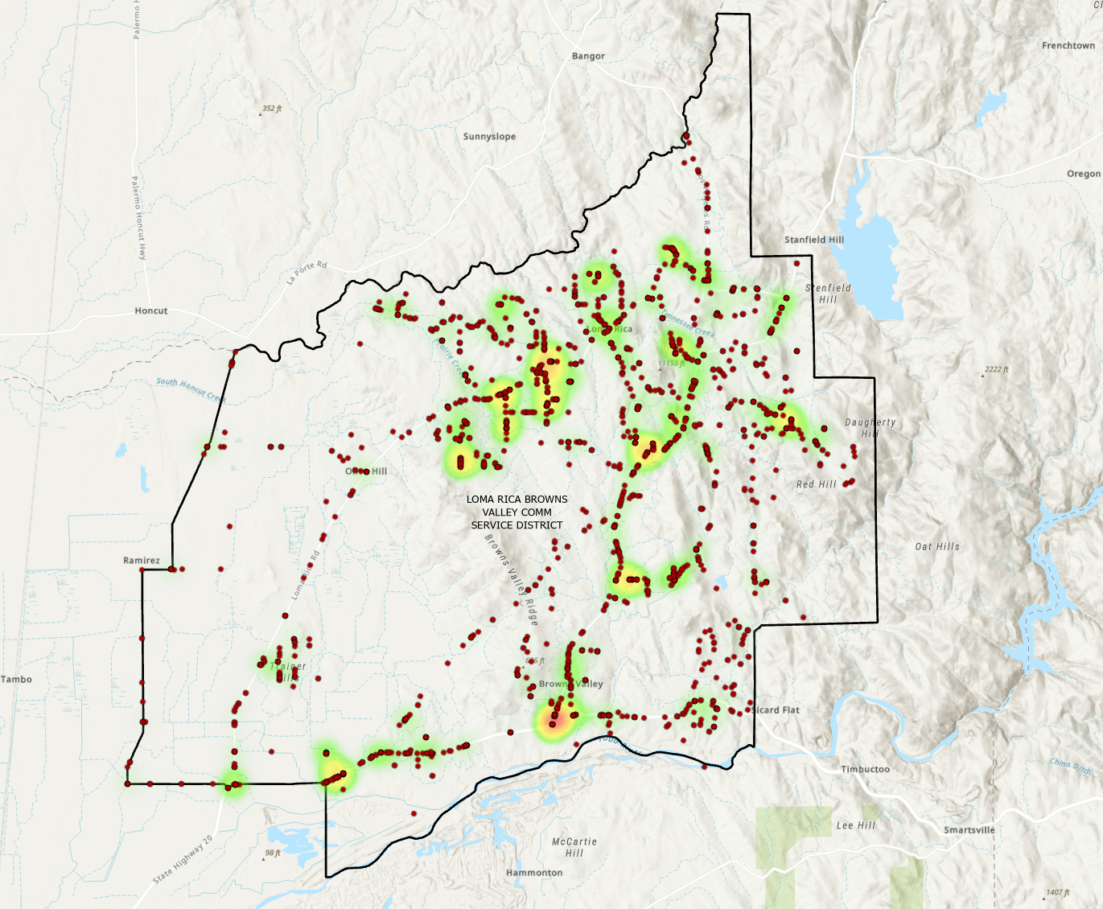

When Incident Volume is compared to District Facilities it appears the location selection for fire stations is reasonably close to the historical need. Future evaluations of facility locations will evaluate the need to add another fire station towards the West end of the district.

Type and Density of Structural Development

As with population, the density of development is directly related to calls for service. Type of development also dictates the required level of service. Size, construction type occupancy, hazard classification, exposure to other building, and wildland hazard within the developed area are all factors used to determine protection levels. Generally, current development consists of low density, residential / small business construction within wildland hazard areas. Most new construction currently is likely reconstruction of homes lost during the Cascade Fire in 2018. The majority of homes are now built with residential sprinklers. There is currently a county ordinance that allows for reconstruction of homes lost in the Cascade Fire to be rebuilt without residential sprinklers and/or water storage requirements. These homes are rebuilt to the original requirements used at the time of their original construction or last approved permitted remodel.

Response Times of Emergency Resources

The elapsed time required for emergency resources to arrive a fire scene directly relates to the likelihood that responding units will be able to control and prevent the spread of the fire. To a certain extent, the response times are based on station location, availability of staff to respond in a timely manner, and the geographical size of the staffed station’s influence area.

There are six critical time periods related to attacking a fire:

- Elapsed time between the start of the fire and detection
- The amount of time required to report the fire once detected
- Elapsed time in the emergency command center between receipt of the report and the dispatch of fire suppression resources
- Elapsed time between dispatch of suppression resources and the actual response of equipment
- Travel time of equipment to the fire scene
- Time required for emergency resources to begin suppression actively

Automated detection and notification systems, public education, and 911 can enhance the first and second steps. The third through sixth steps are directly controllable by the fire department through the Computer-Assisted Dispatch System, station location, fire suppression personnel who are immediately available for dispatch, a high level of training, efficient dependable equipment, and adequate water supplies.

Fire Flow Capabilities

The term fire flow is used to quantitatively represent the water delivery rate (in gallons per minute) required to control a fully involved fire in a particular structure.

The concept of fire flow and the corresponding equations to compute fire flow requirements are widely accepted by fire protection, engineering, and insurance professionals. The District as well as the California Department of Forestry and Fire Protection (CAL FIRE), recognizes the National Fire Protection Association Standard 1142 and 1231, Standard on Water Supplies for Suburban and Rural Fire Fighting in determining required fire flow. The District can also apply the standards of the California Fire code to new subdivisions. Required fire flow is determined by building size, construction type, occupancy hazard classification, and exposure risk. The ability to deliver the required fire flow is dependent upon three elements:

- Available water supplies
- Pump capacity of the fire apparatus
- Sufficient fire service personnel to apply the water

The California Building Standards Commission approved the State Fire Marshal’s Building, Fire and Residential Code adoption package and placed into effect the addition of residential fire sprinklers in all new one-and-two family dwellings and townhouse construction statewide. Approved automatic sprinkler systems can reduce the required fire flow by up to 75% (This does not eliminate the need for a fire department response).

Historically, there have been few emergency water supply systems constructed within the District. Since the adoption of Public Resources Code 4290, however, new subdivisions have been required to install water systems with delivery requirements determined by the size of the development. Fire suppression for the majority of the properties served within the District depends on water transport to the incident and / or the ability of responding equipment to pump water from ponds or irrigation ditches. The District supports plans within the Yuba County Hazard Mitigation Plan for placement of water storage tanks throughout the foothills for fire suppression purposes. As noted earlier, Yuba County requires installation of emergency water storage tanks (minimum 3,000 gallons) for new construction and residential improvement projects requiring a building permit.

In the Summer months, water is available through a system of local irrigation ditches, which do not flow during the Winter. The limited available water during this time may be mitigated by increasing available storage at the existing Stations.

Staffing Levels

Staffing is the single most important and, for “paid” departments, the most expensive element of a fire protection system. There have been numbers studies, and much debate, about the relative effectiveness of fire companies at various staffing levels. Historically, staffing levels of fire companies have been based more on the ability to pay for or staff equipment for emergency response. NFPA 1720 is one of those standards that assumes the following criteria: 2000 ft ² structure, two story, single family home, and without a basement. The following chart shows the recommendations of NFPA meeting that minimum criteria.

Demand Zoneª | Demographics | Minimum Staff to Respond^{b} | Response Time (minutes)^{c} | Meets Objective (%)
Urban area | >1000 people/mi² | 15 | 9 | 90
Suburban area | 500–1000 people/mi² | 10 | 10 | 80
Rural area | <500 people/mi² | 6 | 14 | 80
Remote area | Travel distance ≥ 8 mi | 4 | Directly dependent on travel distance | 90

The Insurance Services Office (ISO), recommends six person engine companies, which could only be considered by the most affluent entities.

Studies show that company effectiveness is directly related to staffing levels and that, within limits, company size may be more critical in timely fire control than response time. For safety and effectiveness, three person companies should be the recommended minimum. The coupling of an all-volunteer fire company and a minimally staffed (in non-fire season) paid company, can pose on scene staffing problems.

The Loma Rica / Browns Valley Fire Department is a combination paid / volunteer Fire Department. Through contract with the CAL FIRE, the district funds continue operations (minimally staffed) of the CAL FIRE Loma Rica station during non-wildland fire season (generally late fall, winter, and early spring). The District utilizes a volunteer resident program in non-wildland fire season to supplement staffing on the engine. The goal of the program is to have one additional person on the engine 7 days a week during the Amador Contract period.

CAL FIRE provides professional leadership through use of the Unit Chief as the Fire Chief, a Battalion Chief as the daily covering duty officer, professional training through use of CAL FIRE officers, and access to state resources. While CAL FIRE personnel normally provide first-in response within the stations immediate influence area, on scene staffing requires volunteer response. Additionally, due to the size and terrain of the District, as well as the location of the Loma Rica station in relation to many outlying incidents, company volunteers are frequently the first-in responders. The basic drawback of relying on volunteers is the uncertainty of their immediate availability for an emergency response. This has its greatest effect during the daytime hours when most volunteers are at their primary places of employment. Another disadvantage of volunteer staffing is that response times are increased by the time required to travel from their location at the time of the alarm to the fire station or the incident in private vehicles. The requirements for volunteer firefighter training have been increased substantially over the past few years due to new OSHA regulations. This has had a profound effect on the number of volunteers on the roster and has discouraged many potential new volunteers from joining. Because of the above, four volunteers are required to guarantee one responding person (based on state wide averages). ISO rating will certainly increase with additional volunteers and documented training.

At times throughout the year, particularly during Fire Season, staffing is temporarily increased due to fire activity, both actual and anticipated. This may include a Water Tender, additional Overhead and staging of other resources. Converting the administrative space at Station 62 into living quarters could provide a strategic location for additionally staffing, incident command posts and staging.

Staffing Level Assumptions For This Plan Include:

      - District funding dictates the continued use of and reliance on volunteers
      - Volunteer morale and organizational pride must be maintained at a high level
      - Volunteer recruitment is essential to the continued viability of the department
      - Contract with CAL FIRE must continue
      - Fire personnel must have the best training available

FIRE PROTECTION OBJECTIVES

Land use within the Loma Rica / Browns Valley area can generally be defined as rural in nature, with a mixture of agricultural, small-scale commercial, and except for few exceptions, low residential densities (consisting of one dwelling unit per five acres or greater). Public facilities generally consist of three public schools, a small number of churches, three gas stations with small markets, four small restaurants, small private day care providers, residential care center, commercial feed store, three auto repair shops, landscape material business, RV repair shop, the Loma Rica Hall, and the Lion’s Club Community Hall. The Dollar General as the only medium retail commercial enterprise located in the District.

Fire Prevention

Objectives:

- Ongoing efforts to educate existing residents to install smoke detectors
- Support County requirement that all new dwellings install smoke detectors at the time of construction
- Support County requirement for minimum emergency water storage tanks.
- Ensure all residences in the district are compliant with PRC 4291
- Ensure HOA’s are maintaining and inspecting private water suppression systems.
- Inspect, update pre-fire plans, and maintain records to conform to the Uniform Fire Code for all existing commercial occupancies on a predetermined schedule
- In co-operation with local schools and service organizations, provide basic fire safety education
- Maintain a fire code, which is consistent throughout the District
- Review all proposed land development and sub-division applications, institute fire protection plans that are consistent with national, state, and county codes.

Fire Suppression

Objectives:

- Control all vegetation fires within the first burning period, per State standard
- Apply extinguishing agent to structure and vegetation fires within 14 minutes of dispatch, full assignment within 25 minutes
- Initiate suppression within 10 minute of receipt of alarm for 90% of all fires within Loma Rica station sphere of influence
- Control 80% of all outlying fires with initial attack assignment
- Through increased use of water tenders, provide an adequate water supply for firefighting and other emergencies
- Support County Hazards Mitigation Plan to obtain grants for the purpose of establishing fire suppression water tanks throughout the foothills
- Support County effort to require emergency water tanks (3,000 gallon minimum) for all residential and small commercial buildings.
- Encourage addition of fire hydrants in all areas of the District
- Maintain sufficient firefighting resources to meet safety and operation needs.

Emergency Medical Services
Objectives:

- Provide basic emergency first aid within 15 minutes of receipt of alarm for 90% of the medical services calls
- Provide all fire fighters emergency medical care training
- Provide all initial response engines with defibrillation units
- Provide initial response engines with extrication equipment
- Work towards addition of ALS capability

Technical Rescue
Objectives:
- Provide Swiftwater rescue capabilities to include equipment, training, PPE, and vehicles that would allow safe response and rescue of victims in the water.
- Enhance and support the RESCUE PROTOCOL COOPERATIVE AGREEMENT with YCSO.
- Develop mutual and automatic aid plans for trench and confined space rescues.

ADMINISTRATION

Objectives

- Annually review and update 5 year plan as part of budget preparation
- Annually review District policies and procedures
- Prioritize purchasing needs relative to PPE, SCBA’s, communications, appliances, hose, rescue equipment, etc.
- Establish standards for equipment purchases
- Maintain automatic and mutual aid agreements with all surrounding fire jurisdictions
- Establish efficient and cost effective vehicle specifications
- Prioritize vehicle replacement schedule and, to the extent possible, maximize existing funding program
- Maintain a scheduled preventative maintenance program
- Continue current accounting system, cost tracking, and monthly Board reports
- Provide an efficient training / incident record and reporting system

TRAINING

Objectives

- Initially train all volunteers to a minimum of PSFA – Medical Training
- All volunteers to meet minimum firefighter training or equivalent.
- Make available and urge all volunteers to increase training level to Emergency Medical Technician including payment of tuition and travel
- All volunteers will maintain required training to meet CA minimums for firefighters
- Make available and urge all qualified volunteers to obtain Driver Operator 1A and 1B status, continue training to achieve Operator status, and include payment of tuition and travel
- Maximize use of CAL FIRE training opportunities
- Provide educational incentives for all volunteers

HAZARDOUS MATERIALS

Objectives

  - Maintain First Responder criteria
  - Participate in and support the Yuba/Sutter Regional Haz Mat Team and increase decontamination support module to support that response.
  - Support county Hazardous Materials Program

PERSONNEL

Objectives

  - Increase efforts to recruit and retain qualified volunteer personnel
  - Maintain equitable workloads for all personnel
  - Maximize, through organizational structure, paid CAL FIRE personnel
  - Maintain Chain of Command – consolidate responsibilities and increase efficiency

COMMUNICATIONS

Objectives

  - Provide all field units with appropriate communications capabilities
  - Support Yuba County JPA and the radio infrastructure
  - Maintain and strengthen communications and cooperation with other agencies

I.S.O. RATING

Objectives

    - Increase availability and affordability of fire insurance within District by maintaining an
I.S.O. rating of 4y throughout the entire District, and 4 in all new subdivisions by requiring installation of fire hydrants.
    - Develop a plan to reduce ISO Rating to 3 / 3Y within the District by all logical means

Fire Department Planning

The 5-person Board of Directors will work towards making the district safer for the residents within the confines of budget restrictions. Over the next 5 years there should be specific goals that are prioritized so the district can concentrate efforts of achieving and/or implementing in addition to the previous information.

Goals

  - Continue the cooperative relationship with CAL FIRE for emergency response.
  - Evaluate the need for a mitigation fee increase.
  - Evaluate the need for an annual parcel tax assessment to fund fire and EMS.
  - Update the District’s fleet by surplus sale of E-61, replace Attack 61.
  - Actively pursue any available grants to offset costs to residents.
  - Implement recommendations to increase ISO rating.
  - Develop increased water storage at existing facilities.
  - Upgrade the living quarter of Station 62 to support any increased future staffing.
  - Upgrade communication technology to include AVL devices in district response vehicles.

APPENDIX A

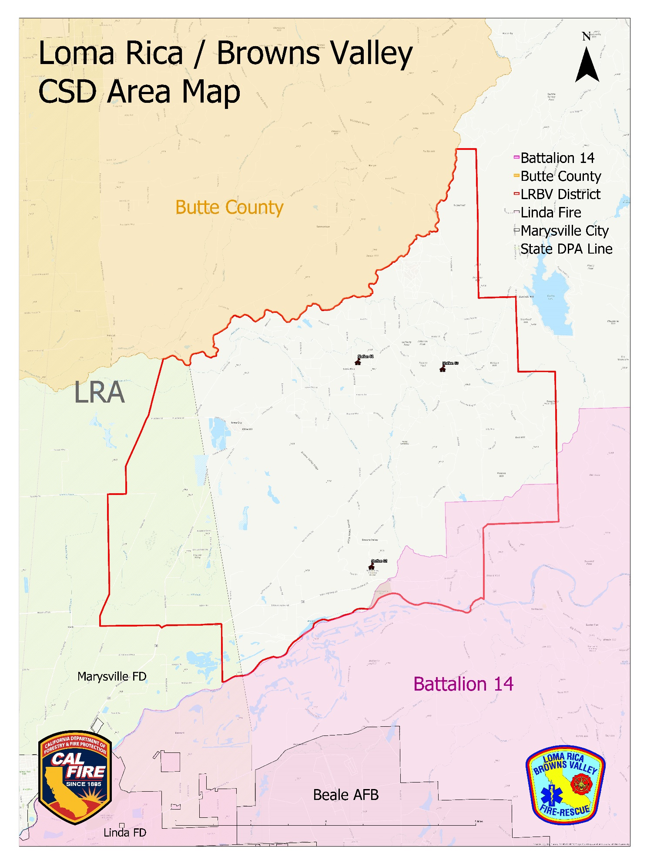
Map

APPENDIX B

Mitigation Funding

MITIGATION FUNDS
5 Year Capital Outlay
Item Description | 2025-2026 | 2026-2027 | 2027-2028 | 2028-2029 | 2029-2030
Engine Replacement
Water Tender Replacement
Mitigation Fund Projections
Beginning Balance | $ 27,738.72 | $27,738.72 | $ 47,738.72 | $ 67,738.72 | $ 87,738.72
Yearly Income (Est) | $ 20,000.00 | $ 20,000.00 | $ 20,000.00 | $ 20,000.00 | $ 20,000.00
Interest (Est. 1.2%)
Annual Expense | $ 20,000.00 | $ | $ - | $ - | $ -
Balance | $ 27,738.72 | $ 66,432.14 | $ 86,432.14 | $ 106,432.14 | $ 126,432.14

APPENDIX C

Capital Spending
Five Year Capital Spending
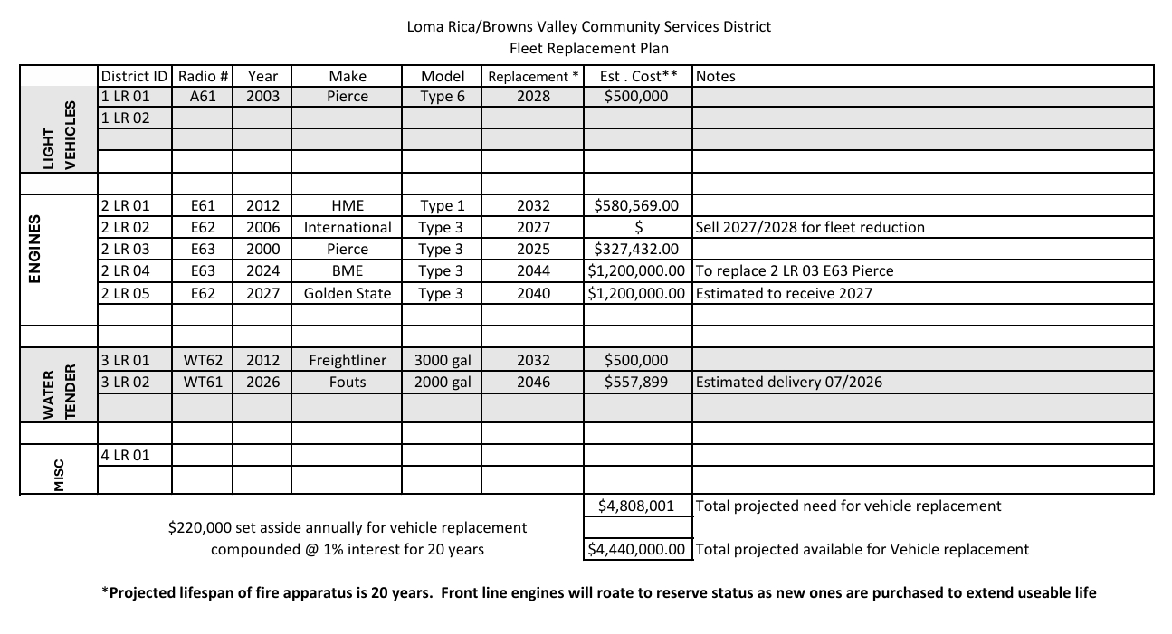

APPENDIX D
 | SUMMARY OF FIVE YEAR PLAN
 |  |  |  |  | CURRENT |  | TARGET
Item Description |  |  |  | GOAL | RESOURCE | DIFFERENCE | YEAR
STAFFING
(A) Volunteers
District Personnel |  |  |  | 10 | 2 | 8 | 2026 / 2027
EQUIPMENT
Fire Engine-Replace Type 3 |  |  |  | 1 | 2 |  | 2026-2027
Fire Engine-Replace Type 1 |  |  |  | 0 | 1 |  | 2022 / 2023
STATIONS / FACILITIES
Water tanks |  |  |  | 3 | 3
TRAINING
First Responder |  |  |  |  | All Volunteers |  | Ongoing
First Responder-Defib |  |  |  |  | All Volunteers |  | Ongoing
Firefighter 1 |  |  |  |  | All Current Volunteers |  | Ongoing
Volunteer Firefighter Certification |  |  |  |  | All New Volunteers |  | Within 18 Months
Driver Operator |  |  |  |  | All Volunteers |  | Ongoing
FIRE PREVENTION
Commercial Code Inspections |  |  |  |  |  |  | Ongoing
Water Systems - Inspections |  |  |  |  |  |  | Ongoing
New Subdivision - In Coordination with County Fire Planner |  |  |  |  |  |  | Ongoing
Continue Fire Pre Planning and Engineering

Summary
Page | 28

APPENDIX E

Equipment

Fire Engine - Type I

500 Gallon water tank Smoke ejector
1250 GPM pump and roll capability 2- 12’X18’ salvage covers 1200' 3" or 2 ½” hose Generator
500' 1 3/4" hose telescoping floodlights
500' 1 1/2" hose Handheld infrared camera
300' I" hose 24' Extension Ladder
150’ ¾” booster line 10' Attic Ladder
4-SCBAs 14’ Roof ladder
Foam system w/ 20 gal tank 1-Chainsaw
2-Fire axes 1-Pulaski
1-Scoop shovel 1-SHRP
1-McCleod 1-Halligan tool
- Pike Pole 1-Bolt cutters
- Handheld lanterns/flashlights 1- 3” hose clamp
1- 2 ½” gate valve 1- 2 ½”X 1 ½”X 1 ½” gated wye
1- 2-½” clappered siamese 1- 2 ½” nozzle w/ shutoff
4- 1 ½” nozzle w/ shutoff 1- 2 ½” playpipe w/ shutoff
1- mobile radio 2- portable radios
Complete extrication/rescue tool Rescue Rope Equipment Complete Set

Fire Engine - Type II / III (Wildland Interface)

500 Gallon water tank Smoke ejector
1000 GPM pump and roll capability 2- 12’X18’ salvage covers 1000' 3" or 2 ½” hose Generator
1000' 1¾” or1½” hose telescoping flood lights
800' I" hose Portable Pump
150' 3/4" booster line 24' Extension Ladder
4-SCBAs 10’ Attic ladder
Foam system w/ 20 gal. tank 14’ Roof ladder
2- Pulaski 2- McCleod
2- SHRP 1- Chainsaw
1-Bolt cutter 2- Handheld lanterns/flashlights
1- 3” hose clamp 1- 2 ½” gate valve
1- 2 ½”X 1 ½”X 1 ½” gated wye 1- 2 ½” clappered siamese 1- 2-½” nozzle w/ shutoff 4- 1 ½” nozzle w/ shutoff
1- 2 ½” playpipe w/ shutoff Complete extrication/rescue tool
1- mobile radio 2- portable radios
Rescue Rope Equipment Complete Set Complete extrication/rescue tool

Water Tender

1800 or 3000 Gallons water tank Portable folding tank 500 GPM pump and roll capability Foam system
500’ 2 ½ or 3” hose Portable pump
400’ 1 ¾” or 1 ½” hose 2-SCBA's
350 horsepower 1- Pulaski
Automatic transmission 1- SHRP
Rear dump valve 1- McCleod

Quick Attack Extrication Equipment

1-ton chassis Complete extrication/rescue tool
4 wheel drive 1-set Air bags
1- mobile radio 1- portable radio
Towing hitch Utility box
Skid mount pump and tank Rescue Rope Equipment Complete Set

